|  |
| --- |
| Computing Technology Inquiry Project |
| COS10026  Semester 1, 2024 |
|  |
|  |
|  |

|  |  |
| --- | --- |
| Member Name | Member ID |
| Paing Chan | 102783895 |

|  |
| --- |
|  |

Table of Contents

1.0 Introduction 2

1.1 Website Introduction 2

1.2 Objective 2

2.0 Website Content 2

2.1 Purpose and main content of each page 2

2.2 Html Markups 4

2.3 Site Map 4

3.0 Website Style 5

4.0 Key features 8

5.0 Conclusion 9

5.1 Summary of the report 9

5.2 Recommendations for future improvements 9

6.0 References 9

# 1.0 Introduction

## 1.1 Website Introduction

This is the collaborative project between Swinburne University of Technology Sarawak and Sarawak Society for the Deaf (SSFD) aimed at collecting an open-access dataset for Malaysian Sign Language (MSL) in the medical context. This initiative aims to bridge communication gaps within the healthcare sector for the deaf community in Malaysia.

## 1.2 Objective

The primary objective of the report is to showcase the use of HTML CSS in developing responsive and user-friendly website pages for MSL and SSFD organizations.

# 2.0 Website Content

## 2.1 Purpose and main content of each page

**Index.html**

Our home page is designed to offer a comprehensive overview of our organization and the services we provide. At the top, users are greeted with a welcoming header featuring our organization's name. The navigation menu allows easy access to different sections of the website, including the About and Services sections. The About section is prominently displayed, offering textual information about our organization, accompanied by logos on each side to visually represent our identity. Additionally, interactive flip-over cards are integrated into the layout, providing users with a seamless way to explore the services we offer. Finally, a footer at the bottom of the page includes essential elements such as navigation links for further exploration, contact information for communication, and links to our social media profiles, ensuring connectivity with our audience.

**Acknowledgements.html**

The page acknowledges contributions to projects related to Malaysian Sign Language and services for the deaf community in Sarawak. It expresses gratitude to individuals such as Ts. Dr. Sue Han Lee, Alec Vince, Masrur Rahman, and Alison Dwyne, as well as organizations like the Sarawak Society for the Deaf, both on Facebook and through their website. The section also includes source links for further information on the mentioned projects and organizations.

**JoinVolunteer.html**

The "Join Volunteer" page serves the purpose of facilitating the registration process for volunteers interested in contributing to different organizations. It features a structured form where volunteers can input their personal details, contact information, address, preferred organization to volunteer for, availability (full-time or part-time), preferred working hours, and a message explaining their motivation for volunteering. The main content includes the registration form, address information, volunteer options, availability selection, working hours/days, reason for volunteering, and buttons for form submission and reset.

## 2.2 Html Markups

For my contribution, I did html and CSS for

I created a container for the form using <div> so I can easily center the form in the middle of the page

JoinVoluntter.html – form

The inputs fields have pattern and required set to check for validity

I used child <div> elements for user info (first name, last name, …) so I can use flex later to arrange them

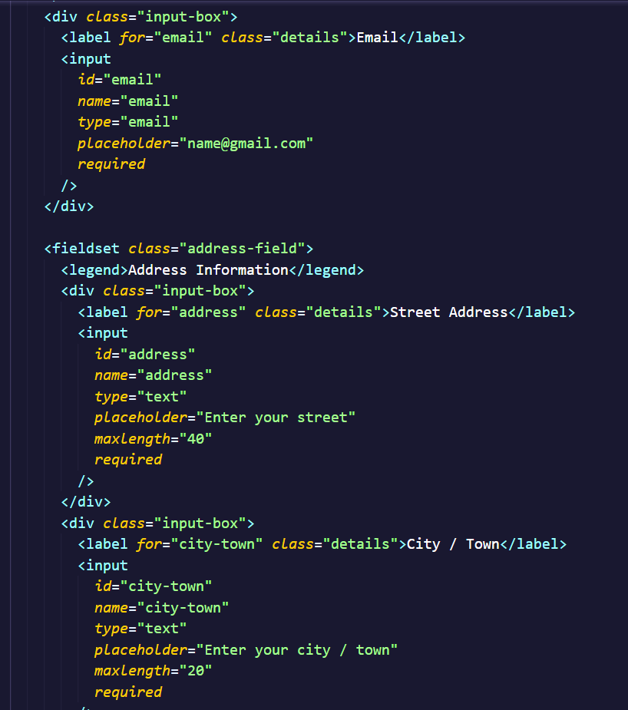

Use of fieldset and legend

Address Information and City / Town inputs with maximum character limit

I used placeholders so the user knows what to type in

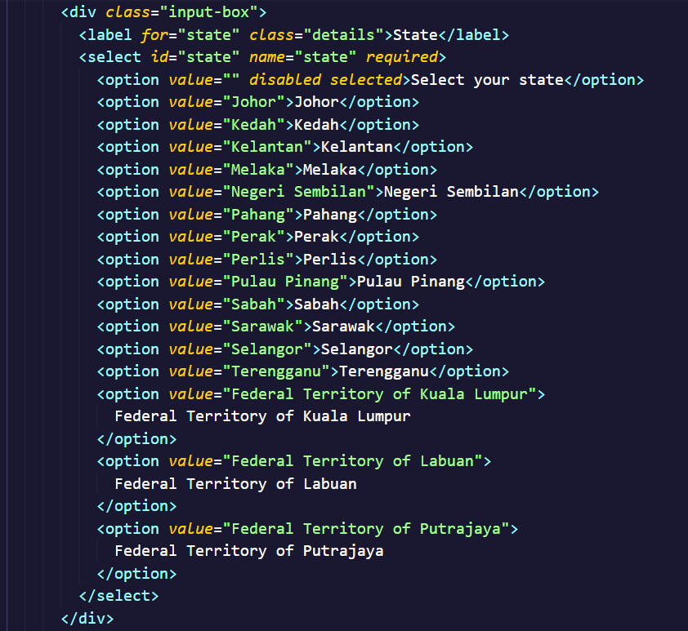

Use of select and options to create a dropdown of states

Phone number pattern is set to accept only + sign, country code and numbers from 0 to 9

Postal code pattern is set to accept only numbers from 0 to 9

Use of radio buttons to ensure users can choose only one option, these will be hidden

Use of span to create a custom radio button later to be styled by CSS

The inputs are given proper name for data storing and id for labels

Input type checkbox to allow users to be able to choose more than one option

Input type “radio” to allow users to choose only one time slot

Buttons are created using input type reset and submit

Index.html – flip-card on hover

All pages – footer

## 2.3 Site Map

# 3.0 Website Style

1

3

3

2

/* Styles for the volunteer form body */

.volunteer-body {

margin-top: 6%; /* To make room for the nav bar */

display: flex;

justify-content: center; /* To place form in the center */

align-items: center;

padding: 10px;

background: var(--clr-primary);

}

**1. Container holding the volunteer form**

.volunteer-container {

border: 2px solid var(--clr-accent);

margin: 3% 0; /* Top and bottom margin 3% of the page */

padding: 25px 30px;

max-width: 700px;

background: var(--clr-primary);

border-radius: 5px;

}

**2. Title of the volunteer form**

.volunteer-container .title {

font-size: 25px;

font-weight: 500; /* To make it distinct as title */

text-align: center;

}

**3. User details and address field sections**

.volunteer-form .user-details,

.volunteer-form .address-field {

display: flex;

flex-wrap: wrap;

justify-content: space-between; /* To make auto spacing */

margin: 20px 0 12px 0;

}

display: flex; allows child elements to be laid out horizontally. Next, flex-wrap: wrap; will wrap onto multiple lines if needed, ensuring that all items fit within the container's width.

# 4.0 Key features

1. Implementation of Flip-Over Card on Home Page



Our website incorporates flip-over cards seamlessly into the Home page layout, offering users an interactive browsing experience. By simply hovering over the cards, users can effortlessly flip them to reveal further details, while a “see more” button enables deeper exploration. Designed to be responsive across various devices, the cards dynamically resize to ensure optimal usability on any screen size. This integration not only enhances user engagement but also improves content visibility, ensuring key information stands out for better attention retention. Overall, it modernizes the website experience, aligning with current design trends and fostering a more engaging interaction with our content

Page applied – index.html

Resources –

<https://www.w3schools.com/howto/howto_css_flip_card.asp>

<https://www.codeguage.com/blog/flip-card-css>

2. Contextual Option Display

We’ve improved the user experience by making the choice between full-time or part-time positions visible only when a volunteer option is selected. This dynamic adjustment simplifies decision-making, reducing clutter on the interface. By showing options contextually, we enhance user engagement and make interaction with our platform more intuitive.

Page applied – JoinVolunteer.html

Resources –

<https://www.w3schools.com/css/css_display_visibility.asp>

3. Responsive Design

For our web design, we ensure that the layout and content of a website alter and adapt to multiple screen sizes and devices. The website includes flexible graphics and media pieces that adjust in size and proportion to the screen size, providing a seamless user experience regardless of the device being used.

Pages applied – index.html, JoinVolunteer.html

Resources –

<https://www.w3schools.com/css/css3_flexbox.asp>

4.

# 5.0 Conclusion

## 5.1 Summary of the report

## 5.2 Recommendations for future improvements

# 6.0 References

Resources:

Malaysian Sign Language Medical Dataset

[https://arekku21.github.io/MSL-Medical/#](https://arekku21.github.io/MSL-Medical/)

Sarawak Society for the Deaf (Facebook)

<https://www.facebook.com/sarawaksocietyforthedeaf>

Sarawak Society for the Deaf (Website)

<https://www.sarawaksocietyforthedeaf.org/>

Tutorial:

w3schools

<https://www.w3schools.com/css/>

GeeksforGeeks

<https://www.geeksforgeeks.org/css-tutorial/>

Code Guage

<https://www.codeguage.com/blog/flip-card-css>